C. Patterson Elementary – CUSD 2024/2025
Comparison between “Classic” and CTA

Two Choices, One School…

“Classic” Patterson  Similar to other CUSD schools | CTA - Patterson  Chandler Traditional Academy | Similar Areas  for both programs
- Room set up varies by teacher  - Journeys HMH Phonics Instruction  - K-2 Journeys and Fundations Phonics Instruction  - Journeys Handwriting Instruction  - Math – MyMath (McGraw Hill) & supplemental materials. Conceptual math focus.  - Engage New York Math Sprints  - Instructional strategies may vary by teacher - including whole & small group, centers, & cooperative learning  - Homework policy (M-Th)  Kinder……………10-15 min.  1st & 2nd ………….10-25 min.  3rd & 4th ………….20-30 min.  5th & 6th ………….30-50 min.  *Additional AR reading minutes may be required | - Desks face front of room  - Spalding Phonics  Instruction  - Spalding Handwriting Instruction  - Math: K-6th- My Math  (One year ahead curriculum)  *5th and 6th Grade use the Glencoe curriculum  - Engage New York Math Sprints  - Primarily whole-group  direct instruction  - Poem recitations  - Homework policy (M-Th)  Kinder……………15-30 min.  1st & 2nd ………….15-30 min.  3rd & 4th ………….25-40 min.  5th & 6th ………….40-60 min.  *Additional AR reading minutes may be required  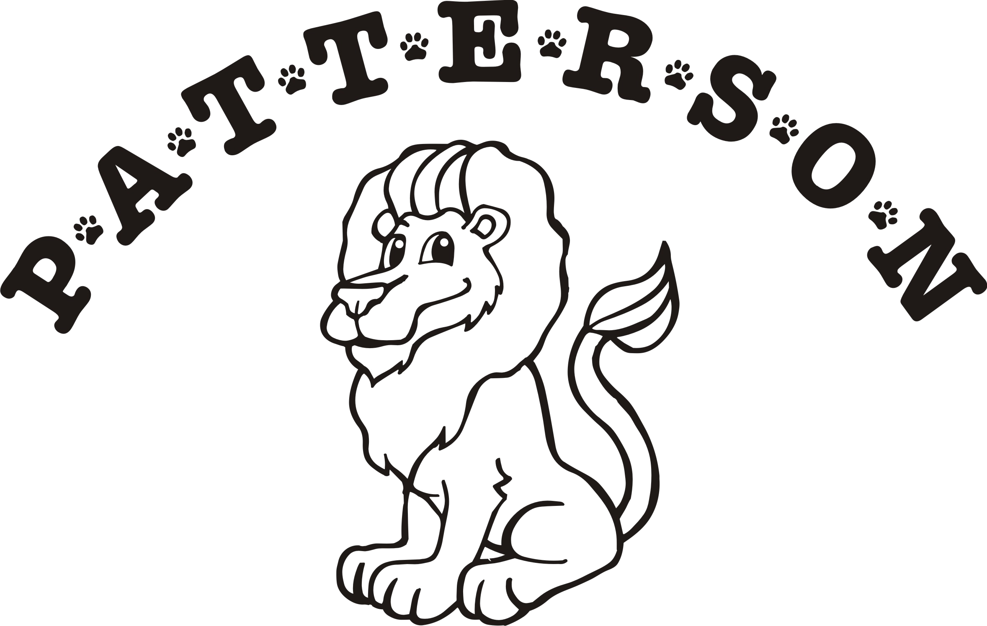 | - Journeys Reading Curriculum  - CUSD Dress Code  (No Uniforms)  - School-wide discipline policy  - Students are at variety of skill levels  - Defined STEM projects  - Science, Social Studies, writing materials  - MobyMax accelerated/intervention practice  - Character Counts/Be Kind Project  - Thinking Maps  - AR (Accelerated Reader)  - DIBELS 8  - Block schedule for Band, Orchestra, Music, & PE (5th & 6th Grade only)  - Specials - PE, Music, Library, & Technology (K-6)  - Special Education Services  - Recess for grades K-6th  - 1:1 Laptops and tablets in classrooms  - Art Masterpiece lessons  - A variety of field trips  - Meet the Teacher and Curriculum Nights  - Chandler Innovation Fair  - Before & After School Clubs  - Student Council  - Battle of the Books  - Spelling Bee  - Running Club  - Active PTO  - Parent Site Council  - Kids Express childcare  - Assemblies  - “Pay It Forward” philanthropy  - Family Projects  - Colors - Navy & Yellow  - Mascot – Pride (as in a family)
Charlotte Upham Patterson Elementary School Chandler Unified School District 7520 S. Adora Blvd, Gilbert, AZ 85298 480-224-3600

